LAB # 01

INTRODUCTION

# OBJECTIVE

To become familiar with the Python Programming by using an Integrated Development Environment

**EXERCISE**

1. **Create a file named lab1.py. Write the following code in the file. Execute it and show the output.**
2. **Code:**

|  |
| --- |
| # My first program    print("\nWelcome in the world of programming!") |

**Output:**

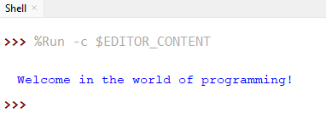

1. **Code:**

|  |
| --- |
| #My second program  print("Welcome in the\n ")  print("world of programming! ") |

**Output:**

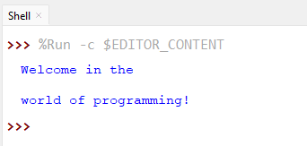

1. **Write a program in Python language that prints your bio-data on the screen. Show your program and its output.**

**Input:**

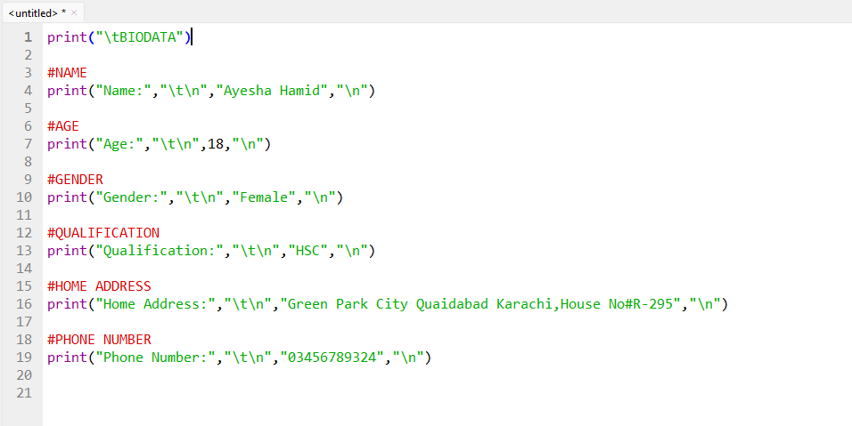

**Output:**

